REMOTE

CONTROL

&

SCREEN

SHARING

www.tsplus.net/advanced-security

sales@tsplus.net

VISIT OUR WEBSITE

CONTACT US

Discover the best alternative to TeamViewer and Anydesk. Provide instant Attended or Unattended remote assistance to your teams or clients anywhere, at any time.

take control of remote clients and troubleshoot problems in one click

1-click remote control

Instant setup & connection

Take control of the screen, mouse, and keyboard of remote clients, in just one click from the end-user. Supports Multi-agent sessions.

Simply download and run a small program on both sides. The end-user can establish the connection just by sharing his ID and password.

efficient support toolbox

unattended access

Upon authorization from the end-user, agents can quickly access unattended remote computers, even when in low power mode (Wake-On-LAN).

Screen sharing sessions include a complete support toolbox: Chatbox, file transfer, remote computer information, remote terminal commands, recording…

Connections are secured with industry standard TLS encryption. Plus, servers are managed by our experts and located all around the world for the best experience.

secure and reliable

customization options

Support agents can create a personalized, streamlined version of the connection client program for their customers, with their logo, brand colors and a simplified interface.

www.tsplus.net/remote-support

sales@tsplus.net

VISIT OUR WEBSITE

CONTACT US

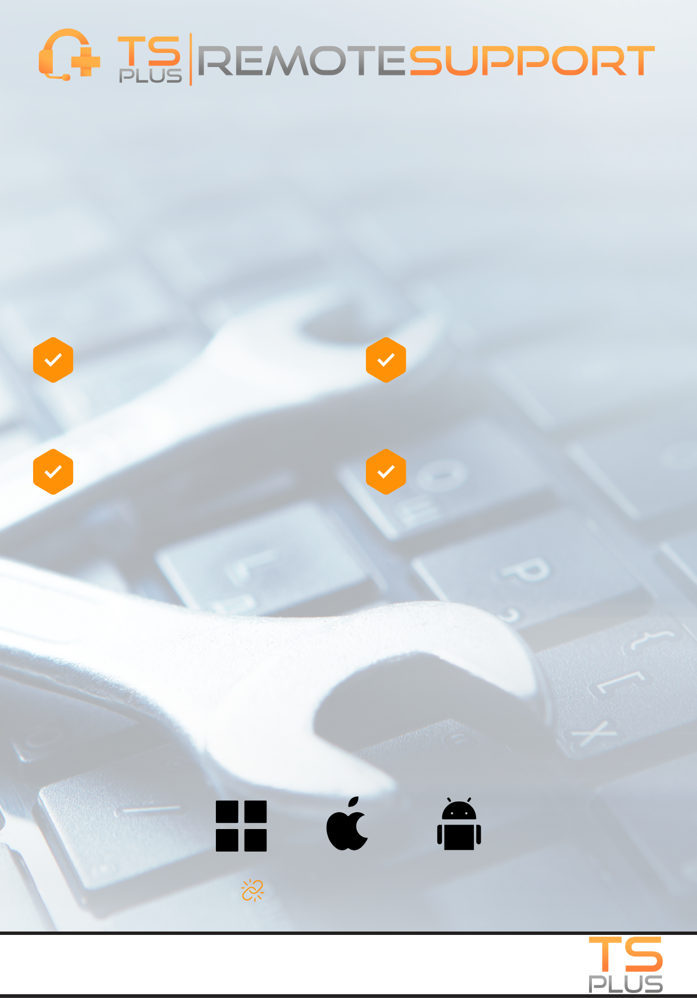

flexible support solution for windows, MAC AND ANDROID

CONTACT US

VISIT OUR WEBSITE

sales@tsplus.net

www.tsplus.net/advanced-security

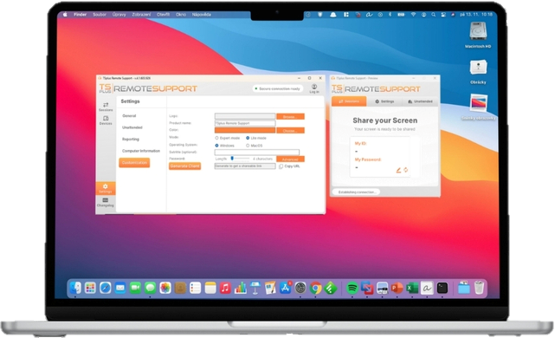

www.tsplus.net/remote-support

[**LEARN MORE**](http://www.tsplus.net/remote-support/)

TSplus Remote Support offers a flexible and versatile solution, available on-premise or in the cloud. Get attended and unattended remote access and control over Windows, Mac, and Android devices. With robust branding and integration options, it offers a complete set of tools for fast, efficient, and secure remote assistance for businesses of all sizes, anywhere.

CONTACT US

VISIT OUR WEBSITE

sales@tsplus.net

Provide Remote Support: Have your support agents assist, support and troubleshoot problems faced by your remote customers.

Provide Remote Training: Use secure multi-user session sharing and collaborative tools to remotely train your teams or clients.

Decrease IT Costs: Significantly save vs alternative solutions, while benefiting from strong security, reliable connections, and powerful features.

Provide Secure Unattended Maintenance: Provide remote IT maintenance such as server updates or setting up tools for your users on various devices.